



Create a database named SalesDB to store information
LAB MANUAL

Disclaimer: The content is curated from online/offline resources and used for educational purpose only
Create a database named SalesDB to store information

Objective:
To create a database and apply various SQL functions, including aggregate, string, numeric, date/time, and conversion functions, to manipulate and analyze data
effectively.

Problem Statement:
The Sales Department requires a database to store product sales data and perform analytics using SQL functions. The task involves creating a SalesDB database with a Sales table and performing specified SQL operations for data aggregation, string manipulation, numeric rounding, date/time handling, and data type conversion.
Requirements:
- MySQL Database installed (Workbench or Command Line).
- Basic understanding of SQL syntax.
Procedure:
Step 1: Start MySQL Server:
Open the command line or terminal.
On Windows: Use MySQL Workbench or run the mysql command.

Step 2: Create the Database
Execute the following SQL to create the database

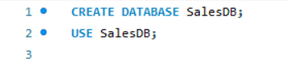

Step 3: Create the Sales Table
Define the table structure:
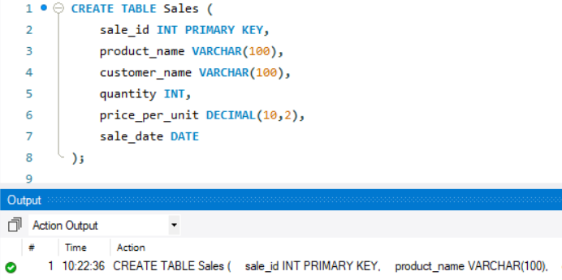

Step 4: Insert Sample Data
Add records for testing SQL operations:

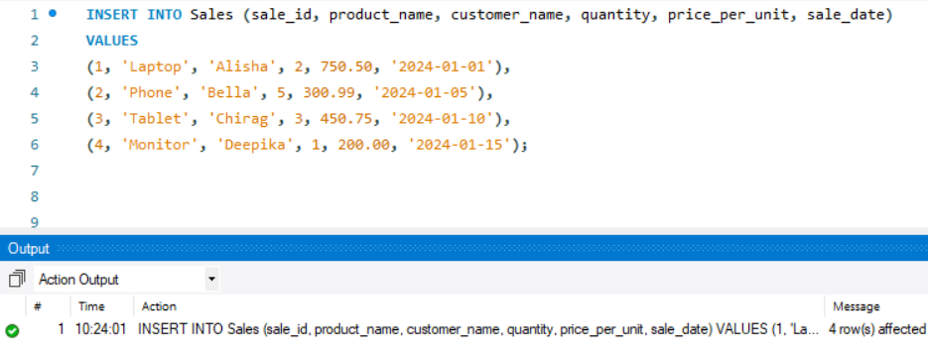

A: Aggregate Functions
(i) Count total number of sales:

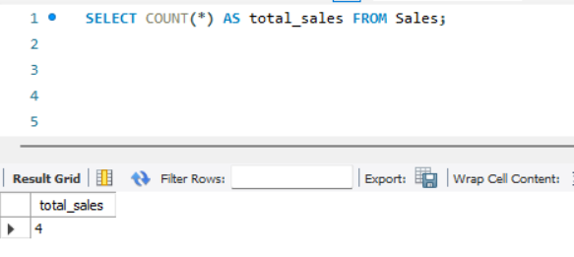

(ii) Calculate total and average revenue:
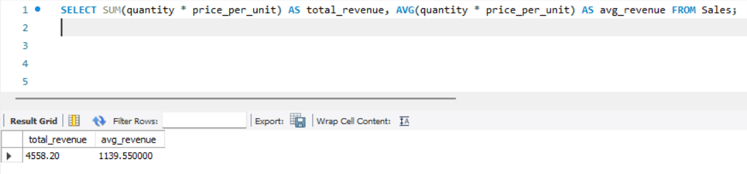

(iii) Find highest and lowest sale prices:
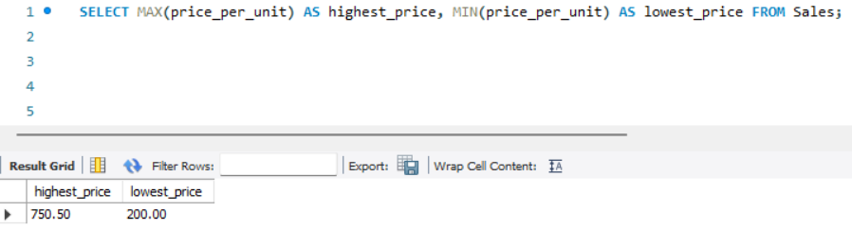

B: String Functions
(i) Create a description string:
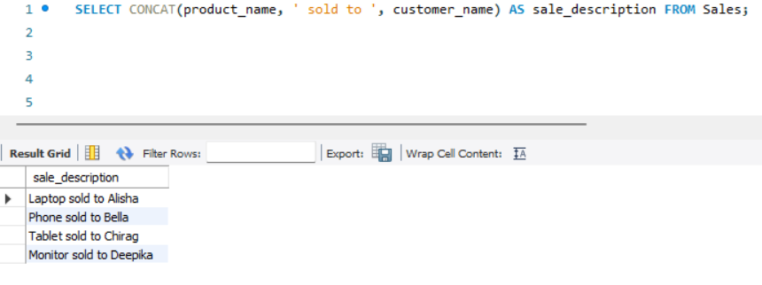

(ii) Display product names in uppercase and lowercase:
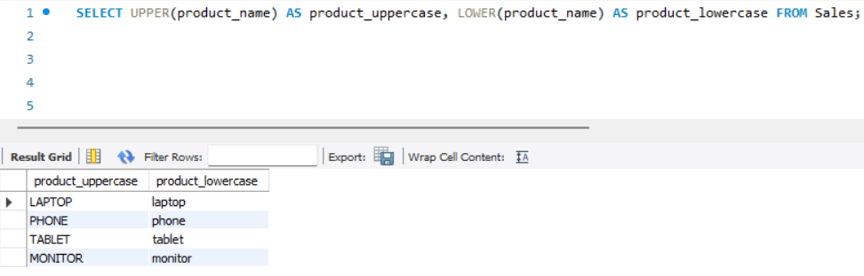

C: Numeric Functions
(i) Round average price to nearest whole number:
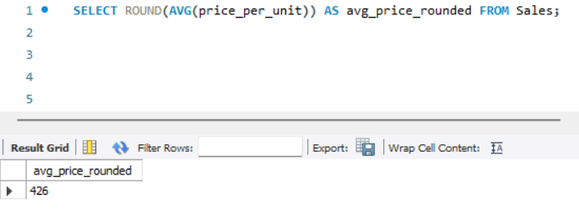

(ii) Show ceiling and floor of average price:
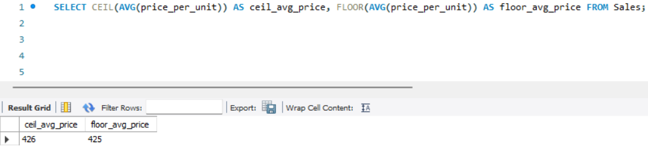

D: Date/Time Functions
(i) Display current date and time:
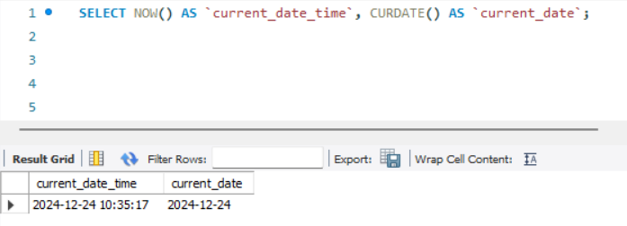

(ii) Add 30 days to sale date:
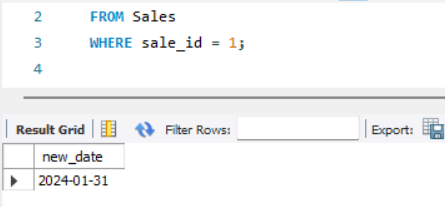

E: Conversion Functions
(i) Convert quantity to VARCHAR:
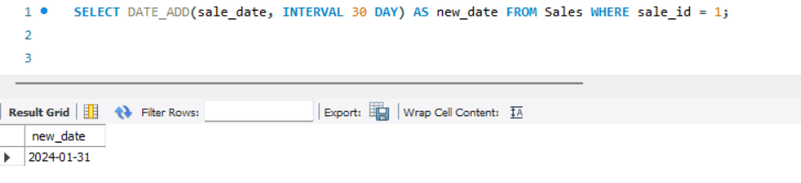
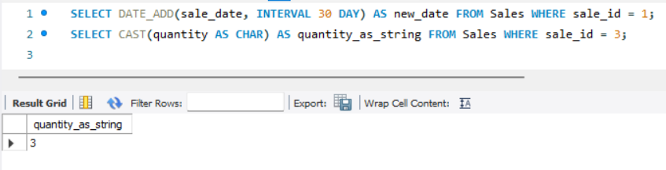

(ii) Convert price_per_unit to CHAR:
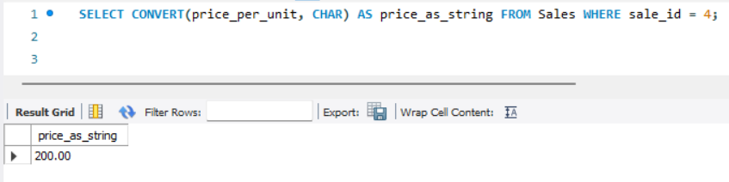

Output:
The queries was successfully executed

